**Analysis of Sales Orders**

**Examining the Effect of 2017 Hurricanes and Wildfires**



Contents

* Introduction
* Statements of Trend Observations and Conclusions and Forecast Explanations
* Visualizations of Sales Order Trends
* Percentage of Orders Breakdowns
* Forecasting Models Visualizations

**Introduction**

This report contains the Sales Order data for Andrew’s Cookies, encompassing the months of January 2016 thru January 2018. The purpose of the report is to investigate the impact on current and future Andrew’s Cookies Sales Orders of the Hurricanes and Wildfires that occurred in the latter half of 2017. The Wildfires investigated occurred in California. The Hurricanes were in the Gulf Region and South Eastern United States.

Originally I chose to investigate the impact on California, Florida, and Texas compared to the rest of Andrew’s Cookies Sales Orders over the time period in question. I also chose to investigate to see whether an impact was observed on Georgia, North Carolina, and South Carolina.

The data does not assume or take into account any events that have or may occur outside of the scope of the natural disasters stated above or any data that exists outside of the Dates and Dollar Amounts of Sales Orders that occurred within the stated dates.

From August 2017 to December 2017 there were 209 registered wildfires of varying size in California according to the government of State of California. Reference: <http://www.calfire.ca.gov/general/firemaps>

Four major storms affected the Gulf and South East Regions of the United States beginning in the last week of August 2017 thru October 2017. Reference: [www.cnn.com](http://www.cnn.com)

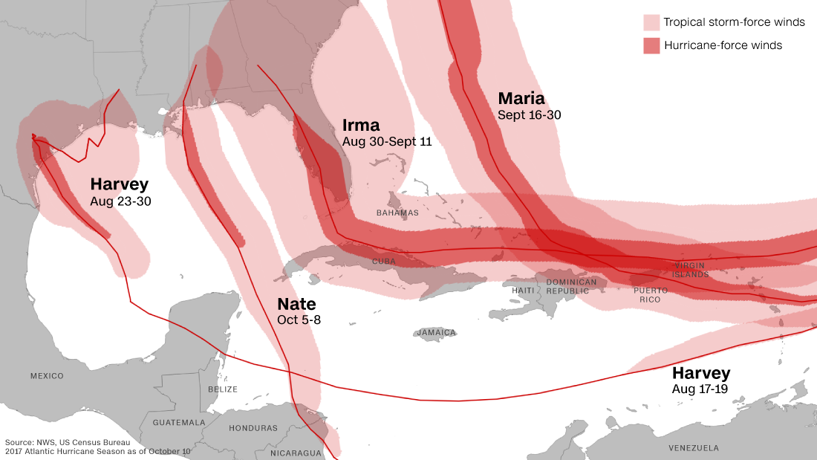

**Trend Observations:**

Trend Observation 1: The sales order dollar amounts exhibit a positive overall trend from January 2016 thru January 2018.

Trend Observation 2: A strong seasonal trend in sales orders is present throughout each year. There does not exist much month to month correlation, however there exists a strong year over year seasonal trend in the data.

Trend Observation 3: The breakdown of orders within the months and states affected by the natural disasters, compared year over year, do not indicate any significant impact caused by the Hurricanes or Wildfires respectively or collectively.

**Conclusion:**

It is my conclusion based on the investigation of affected states and the time periods of the Hurricanes and Wildfires that there was a not a significant effect on orders.

Andrew’s Cookies experienced its strongest January sales orders in history in January 2018. It is my conclusion that based on the data contained in this report those numbers must be attributed to something other than the Hurricanes and Wildfires of late 2017.

It would be interesting to investigate correlations between sales orders and data that exist outside of this investigation. For instance between things like growing brand awareness (Media, Social Media, etc.) There also may be a correlation between orders and measures on the overall economy at large.

My conclusion is that a forecast of sales orders for 2018 should be expressed more closely by Model 1 than Model 2 with regards to the question of the effect of the Hurricanes and Wildfires on sales orders, as explained below.

**Forecasting:**

Two ARIMA (Autoregressive Integrated Moving Average) Forecasting models are provided at the end of this report. Model 1 assumes that the storms had no impact and that January was a legitimate increase in sales order volume that should indicate a stronger year than last year looking forward.

Model 2 assumes that January 2018 is an anomaly of strong sales and should be removed from the Time Series used to model a forecast. Throwing out January provides us with modeled numbers for January thru August, instead of the Actual January numbers that are included in Model 1.

Equation for time series models: **Yt = α + Yt-1+ βt + εt**

**Visualizations of ProCharger Sales Order Trends:**

Visualization of Total Orders

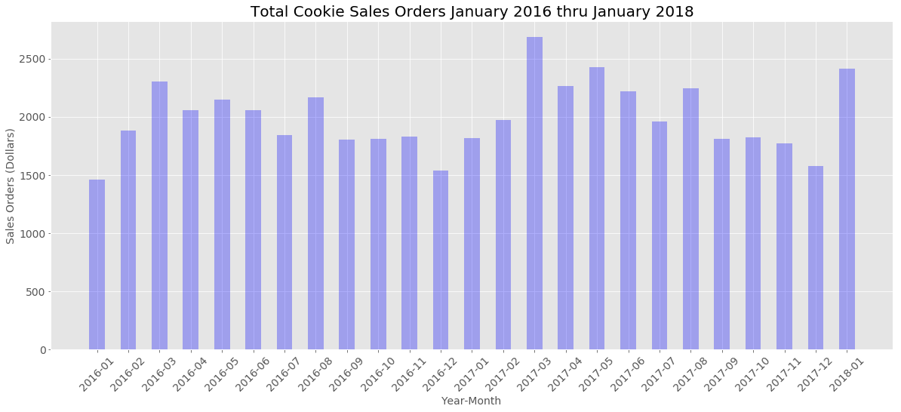

Comparison of Januarys. Positive Overall trend with 2018 as the greatest yet.

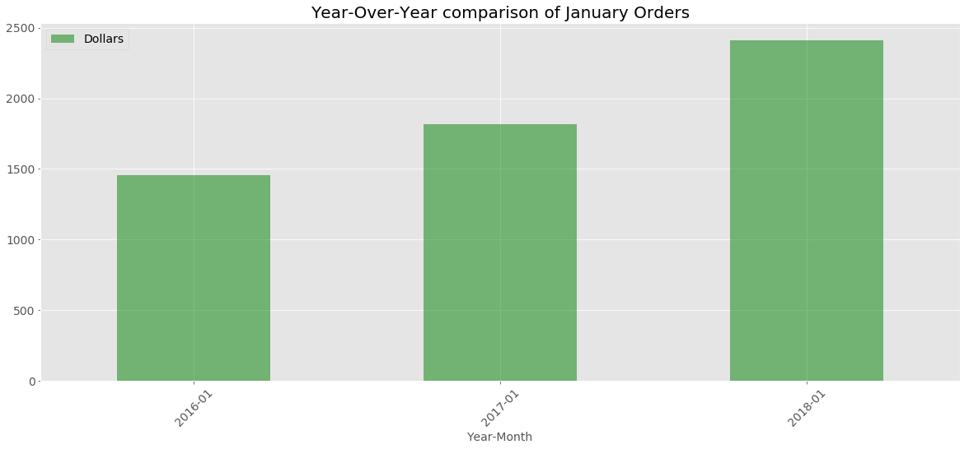

Impact of natural disasters on Sales Orders as broken out by affected states.

**Conclusion:** No Significant Impact on Sales Orders

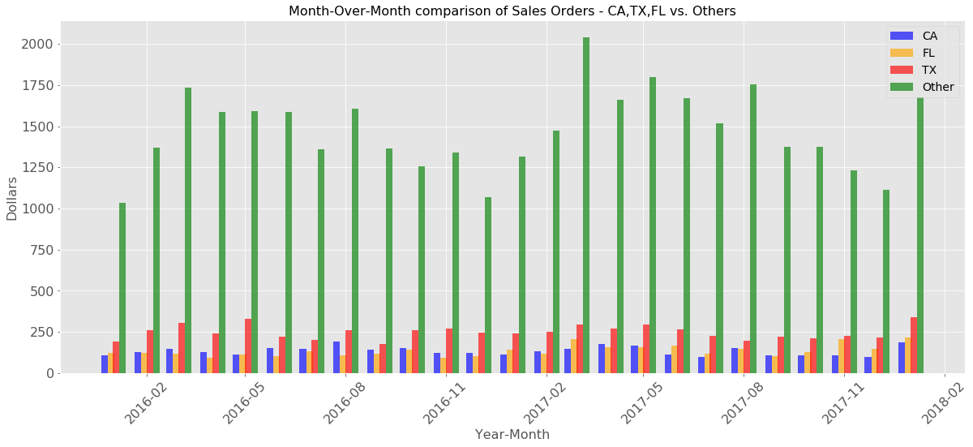

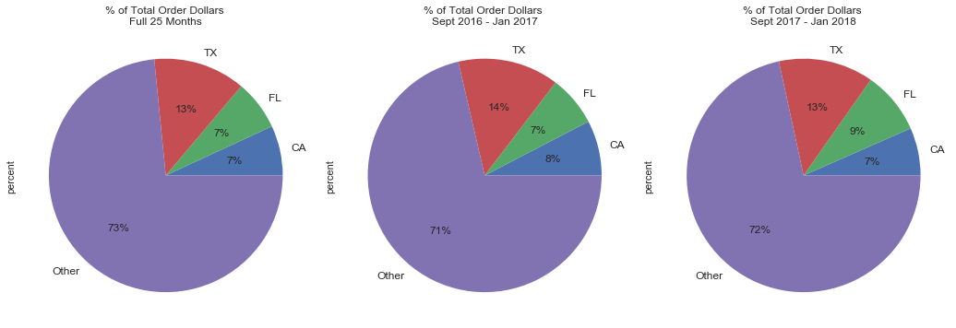

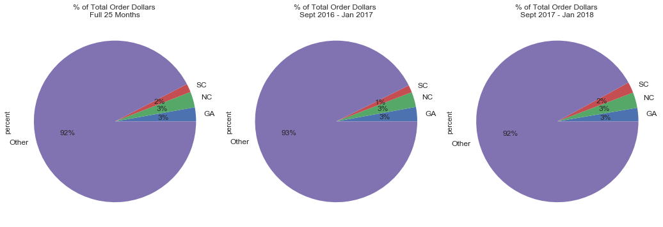

**Forecasting Models:**

**Conclusion:** 2018 should more closely follow Model 1 than Model 2, indicating increased sales order growth for 2018.

**Model 1:** January 2018 is not anomaly. Model includes January 2018. Positive overall growth with strong seasonal trend.

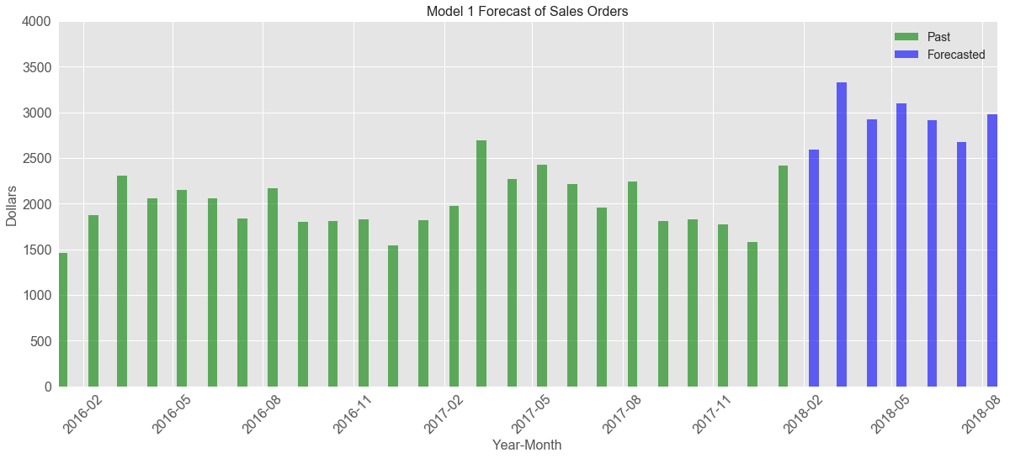

**Model 2:** Assumes January 2018 is an anomaly. Model excludes January 2018. Seasonal trend is present without positive growth.

